User Manual for DY3797L
1, Parts listing and image
Description | Bolt | Washer | Key | Seat | Legrest
Picture | 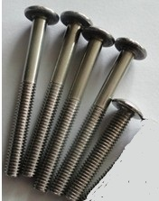 | 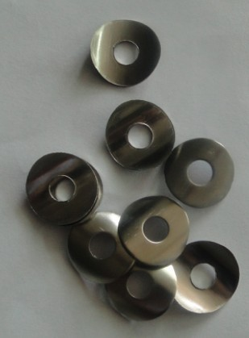 | 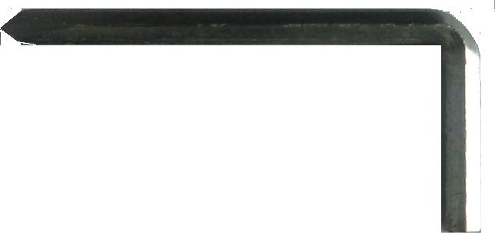 | 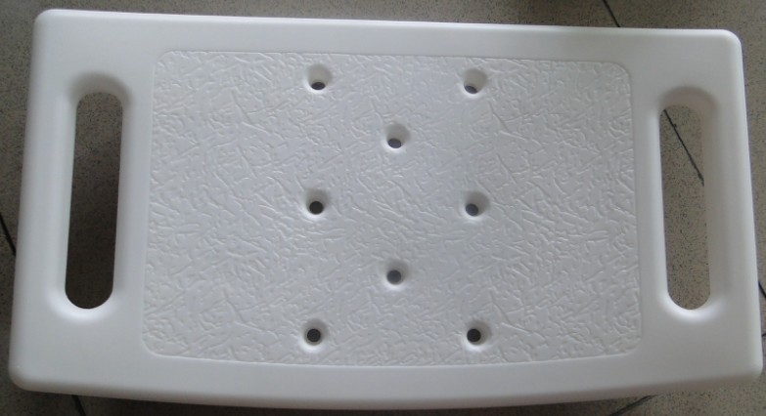 | 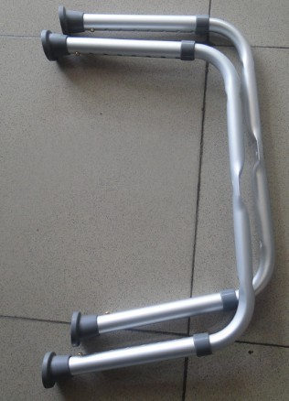

2, How to make the assembly
1， Open the packing and take out all parts from the polybag | 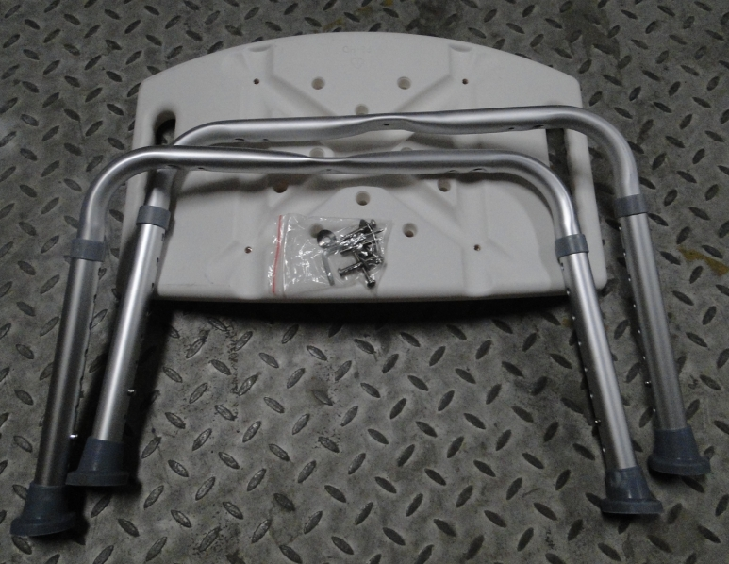
2, Put the washer in the screws | 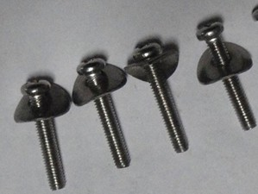
3, Place the seat on a chair with upside down. And place the legrests on the slots. Put the short bolt into the hole in the center where two leg rest cross, and the long bots into the other four holes on the legrest. And lock the bolts with the key. | 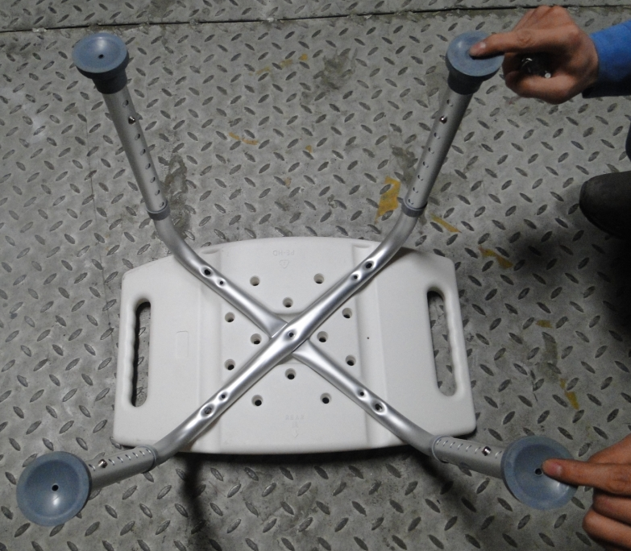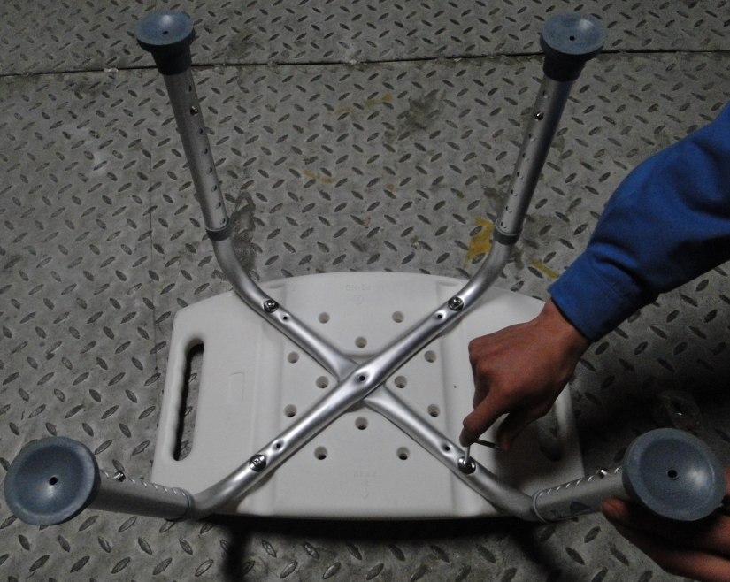
4, Complete assembly. | 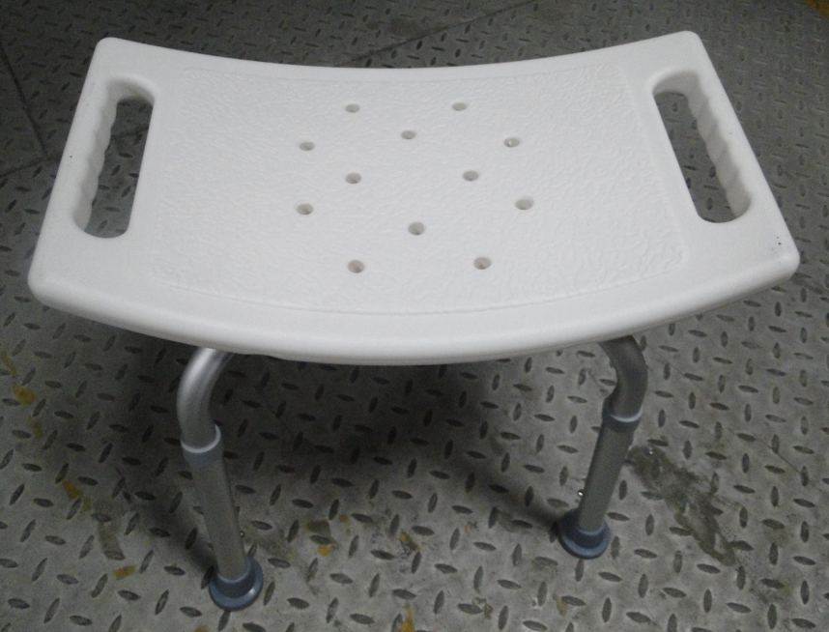

Remark: Lock all bolts with the key available from the tool kit

